Lesson 02 XAS Resource Workbook

**Introduction to EXAFS**

**Charles A. Cardot and Gerald T. Seidler**

*All lessons and all versions can be found at* [*https://github.com/XASResourceWorkbook/XASResourceWorkbook*](https://github.com/XASResourceWorkbook/XASResourceWorkbook)

*This work is licensed under* ***CC BY-NC-SA 4.0***

**

Version History:

1.0 *Month Year*: C.A. Cardot, G.T. Seidler

Lesson 02 XAS Resource Workbook

**Introduction to EXAFS**

**Suggested Introductory Reading**

* Newville (Sections 1 and 2) <https://doi.org/10.2138/rmg.2014.78.2>.
* <https://en.wikipedia.org/wiki/X-ray_absorption_fine_structure>
* Bunker (Chapter 2) ISBN-13: 978-0521767750
* <https://en.wikipedia.org/wiki/K-edge>
* Chen et al, <https://doi.org/10.1088/1402-4896/aae727>
* Lytle The EXAFS Family Tree <https://doi.org/10.1107/s0909049599001260>
* Theory of Extended x-ray Absorption Fine Structure <https://doi.org/10.1103/physrevb.10.3027>

**Overview and Advanced Reading**

<https://www.bnl.gov/ps/userguide/lectures/Lecture-4-Ravel.pdf> A wonderful slide deck hosted on Brookhaven National Lab’s website given by Bruce Ravel. It has lots of good figures and a helpful discussion of terminology.

The EXAFS equation which is referenced later in this lesson has many components and can seem somewhat intimidating at first glance. For a detailed introduction that progressively builds a qualitative intuition for the different components of the equation, see the textbook *XAFS for Everyone* ISBN-13: 978-1439878637 pages 9-14. Additionally, the EXAFS equation in the form we know today comes from a breakthrough discovery from Sayers, Stern, and Lytle <https://doi.org/10.1103/PhysRevLett.27.1204>.

Rehr et al. papers on intrinsic/extrinsic loss and its effects on EXAFS and XANES: <https://doi.org/10.1063/1.2644437> , <https://doi.org/10.1103/PhysRevB.37.6126>

Analyzing EXAFS data is rarely a straightforward process. *XAFS for Everyone* ISBN-13: 978-1439878637 Chapter 4 and Chapters 10-14 gives a substantial introduction to the data reduction and modelling/fitting process. *Introduction to XAFS: A Practical Guide to X-ray Absorption Fine Structure Spectroscopy* ISBN-13: 978-0521767750 Chapters 5.2 and 5.3 discuss data reduction techniques and includes multiple examples from common analytical software, along with some illustrative Mathematica scripts that are helpful for developing an idea of what is going on under the hood.

Development of Methods of EXAFS Spectroscopy on Synchrotron Radiation Beams: Review <https://doi.org/10.1134/S1063774506060022>

J. D. Hanawalt, The Influence of Temperature on the K Absorption of Iron, <https://doi.org/10.1007/BF01339579> (**German version, need English Translation**)

Azaroff (1963) summary of correct theoretical description of XAFS (precursor info, good context for Sayers, Stern, and Lytle paper) <https://doi.org/10.1103/RevModPhys.35.1012>

## **I. Identification**

**Educational Goals**:

* 1. 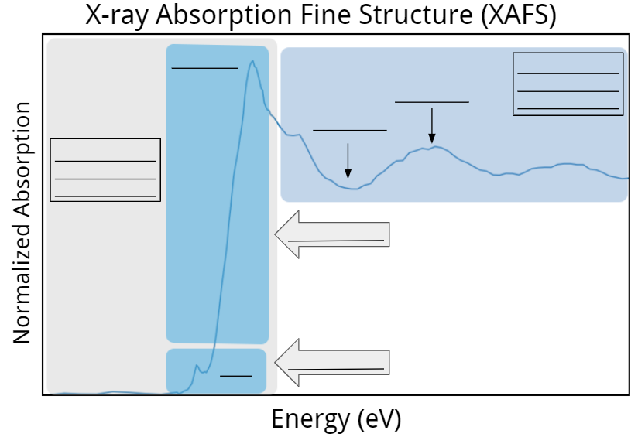Label all parts of the XAFS graph using the terms in the box below it. The XANES components of the fine structure will be addressed in a separate section.

* Pre-Edge
* 1s to nd
* Rising Edge
* Constructive Interference
* 1s to (n+1)p
* Destructive Interference
* X-ray Absorption Near Edge Structure (XANES)
* Extended X-ray Absorption Fine Structure (EXAFS)

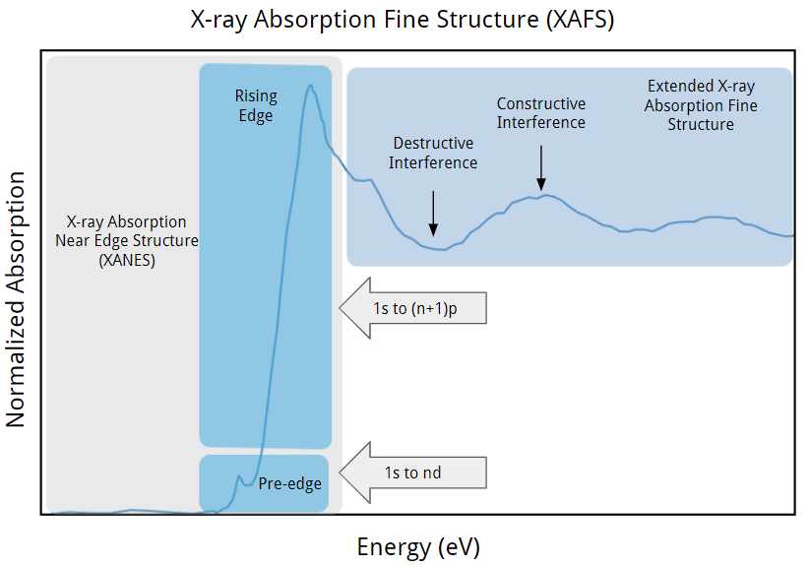

## **II. EXAFS Fundamentals**

**Educational Goals**:

1. What is the physical reasoning behind the constructive and destructive interference observed in EXAFS?
2. What are the main physical properties that EXAFS is sensitive to?

1. Recall that the X-ray absorption process is fundamentally the photoelectric effect, governed by the equation , where is the energy of the incident photon, is the binding energy of the electron, and is the kinetic energy. The photoelectrons created in the XANES region have an energy between 0 eV and roughly 50-100 eV while the photoelectrons created in the EXAFS region have an energy greater than roughly 50-100 eV. Note that there is no strict numerical cutoff between the XANES and the EXAFS region that is applicable for every system. However, the photoelectrons in EXAFS do always have higher energy (and hence higher momentum and smaller wavelength) than the photoelectrons in XANES. Given this, which of the two regions of XAFS are more sensitive to thermal vibrations? Explain why.
2. There are two main types of losses that can affect the XAFS. They are known as intrinsic and extrinsic energy losses and they broaden or dampen the XAFS oscillations. Intrinsic losses come from the collapse of the core hole and are tied to the energy-time uncertainty principle, . Convert the table of core hole lifetimes below from eV to femtoseconds. Which measurements do you expect to have the largest amount of broadening in the EXAFS oscillations? The smallest? (Hint: If you need help converting from eV to fs, recall that Plank’s constant, , equals 1 in natural units)

|  |  |  |  |  |
| --- | --- | --- | --- | --- |
| **eV** | Si (K): 0.48 | As (L1): 3.79 | Yb (L1): 5.53 | U (K) 96.1 |
| **femtoseconds** |  |  |  |  |

1. Extrinsic losses are caused when the photoelectron collides inelastically with the environment around the absorbing atom. Based on what you know from the de Broglie equation, , and the requirement for interference, why do elastic collisions cause extrinsic losses?
2. Both EXAFS and x-ray diffraction can be used to probe order in a material. What regimes are each of these methods most often used to probe? Why is EXAFS not usually used to study the regime that x-ray diffraction is sensitive to, and vice versa?

1. Consider the physical significance of the constructive and deconstructive interference in the EXAFS. Give an expression which relates the wavelength of the photoelectron to the total distance it travels when the interference is constructive (let’s ignore the effect of real atomic potentials for now!). What about when it is destructive?
2. Recall the physical properties that the EXAFS is sensitive which you listed in an earlier problem. Explain **why** EXAFS is sensitive to **one** of these properties in terms of your answers to the previous questions.

## **III. EXAFS Equation**

**Educational Goals**:

Because XAFS is an interference phenomenon, it appears as a modulation on the underlying atomic behavior (in the absence of photoelectron scattering). This underlying behavior is called the ‘atomic background’, and hence is formally expressed as a product of the atomic background () and the XAFS modulation ().



However, as a matter of convenience can be expressed in terms of the measured jump in absorption at the threshold energy ().

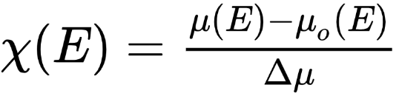

Below are the normalized (edge step equals 1) , , , and for experimental data on Cu Foil. Note that the plots have been multiplied by to make it easier to identify the weaker oscillations at high k.

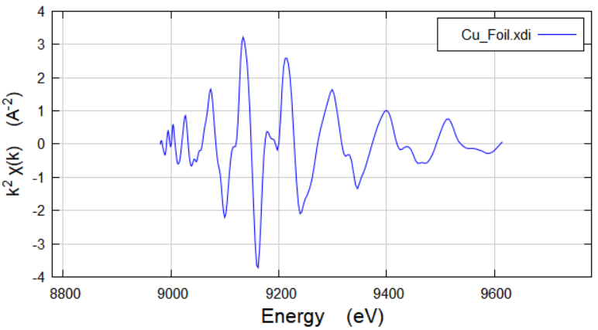 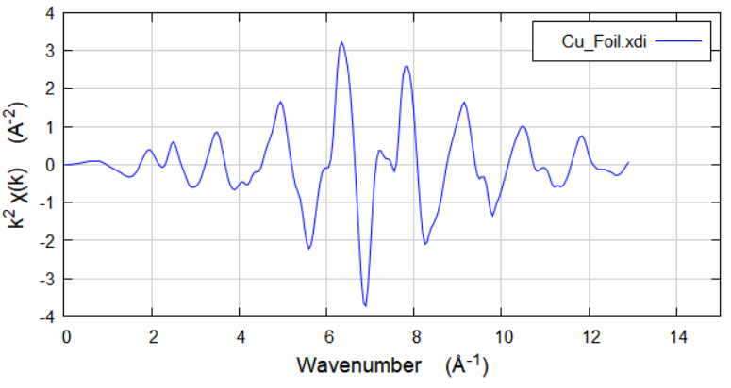

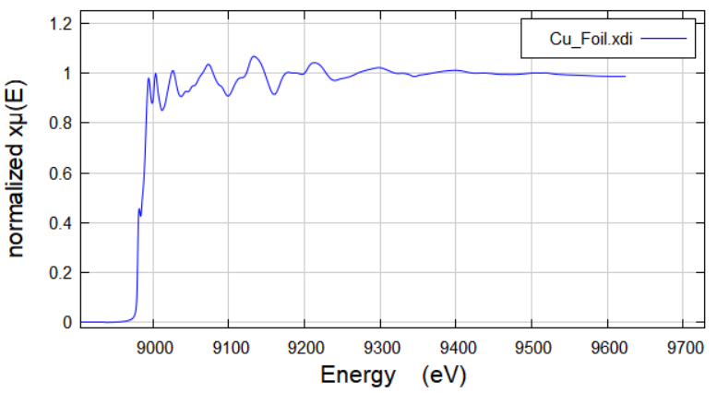 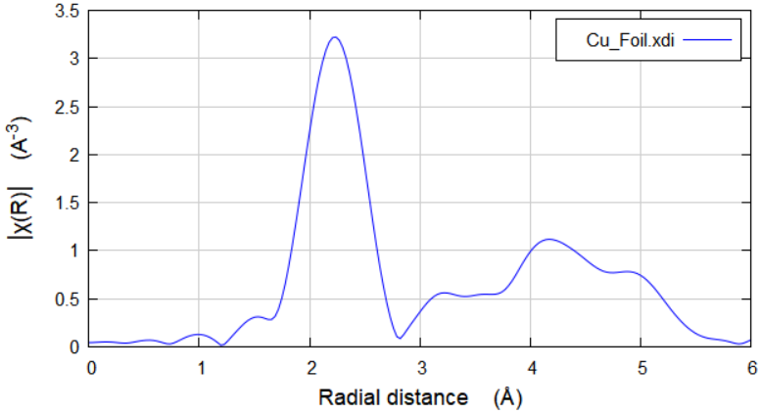

1. A simplified version of the EXAFS equation is given below. The sum is over coordination shells, where the scattering distance is approximately the same for each atom in the shell. However, it is important to note that this form of the EXAFS equation does not account for multiple scattering paths (involving more than just 1 coordination shell). Provide a brief description of some of the key components of the equation.

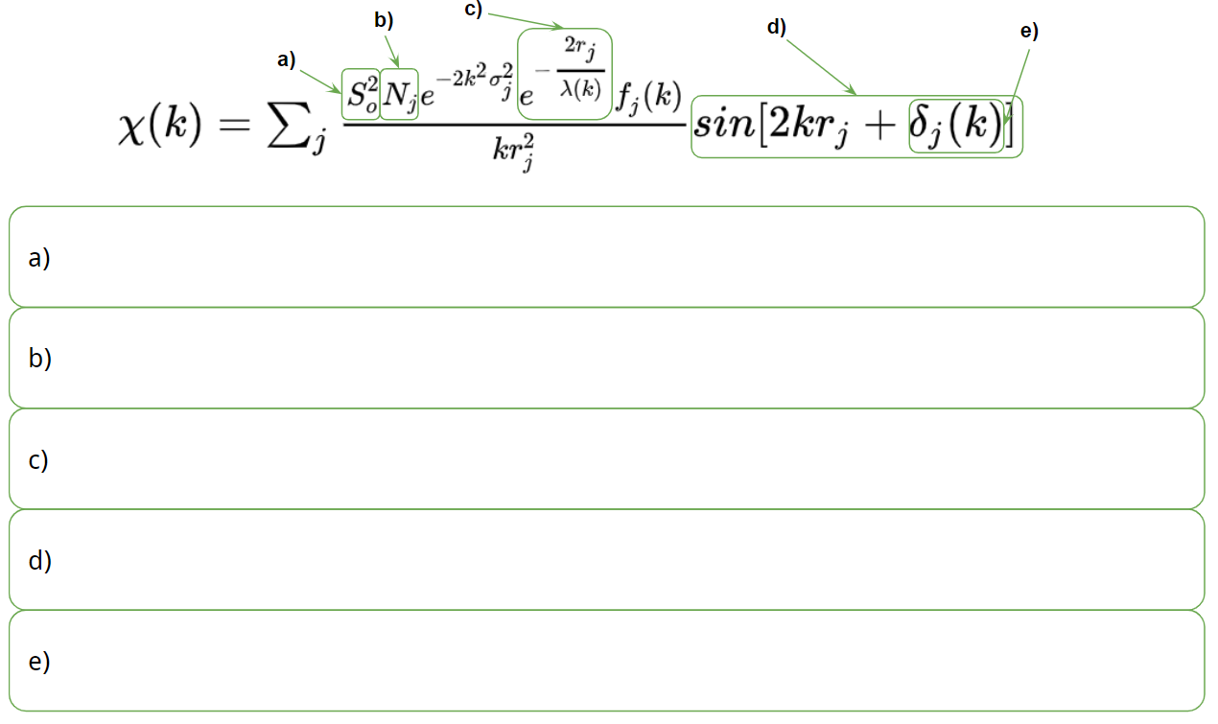

1. The component of the EXAFS equation is known as the Debye-Waller term. How is the component connected to the temperature of the system? Given this, how would you expect the oscillation in EXAFS equation to vary with temperature?
2. Consider a simple diatomic molecule. This has only one important scattering distance, namely the distance between two atoms. Roughly sketch what will look like. (Hint: the sum in the EXAFS equation then only has one term.)

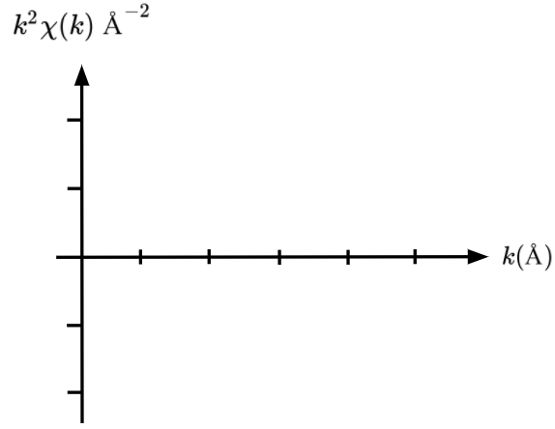

1. Now assume that the distance between the diatomic molecules has been stretched to be 25% longer. Roughly sketch what the new will look like. Are the oscillations faster or slower in k? (Hint: Consider the sinusoidal component of the EXAFS equation.)



1. Depicted below is the symmetrized unit cell for Cu taken from the materials project website <https://materialsproject.org/>. Is has cubic symmetry, with a = b = c = 3.62 Angstroms. The Fourier transform of EXAFS equation in k-space, , gives the EXAFS equation is position space, . This allows us to connect the resonances (peaks) in the EXAFS equation as a function of position with the physical distance the photoelectron travels before being reflected. Match the 4 bumps in the Cu Foil plot with the correct group of neighboring atoms that the photoelectron reflects from. (Note: The radial distances in the will likely be shifted by a constant value compared to the true distance between neighboring atoms. This is due to the term in the EXAFS equation.)

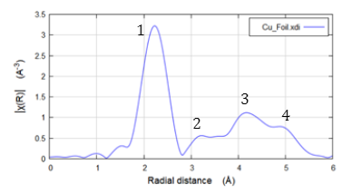 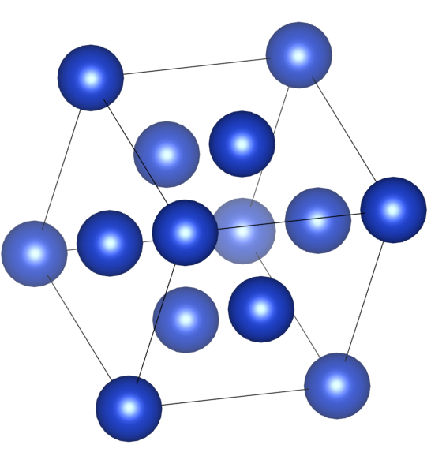

1. Why do we use instead of to represent the EXAFS equation? Consider the physical significant of the oscillations.

1. Below are images of 2D crystal structures, <https://doi.org/10.1107/S0021889811038970>, for Graphene (brown) and NaCl (yellow and green). The absorbing atom is circled in red. Specify the first two coordination shells for both Graphene and NaCl and create a table that gives the coordination number for each shell.

**Graphene NaCl**

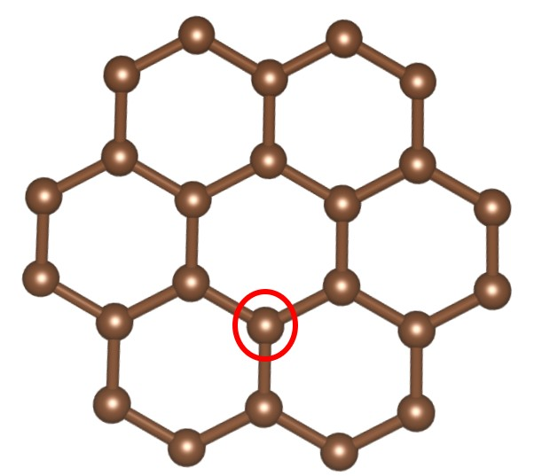 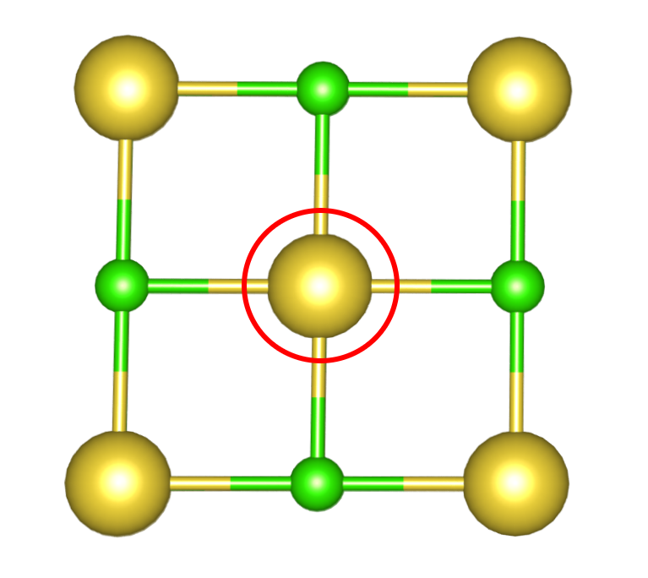

1. Coordination shells are useful for describing the possible scattering paths of the photoelectron, but they do not give the full picture. For example: the photoelectron may exit the absorbing Na, scatter off of the nearest Cl, scatter of a separate Na atom, and then return to the original absorbing Na. This process involves two separate coordination shells but may still have significant contributions to the oscillations in the EXAFS spectrum. On the NaCl diagram below trace out and label the 5 shortest distinct scattering paths (do not consider degenerate paths that arise from the symmetry of the system).

